Insert school header here

##### Semester Two Examination, 2012

##### Question/Answer Booklet

CHEMISTRY

**Stage 3**

|  |  |  |  |  |  |  |  |  |  |  |  |  |
| --- | --- | --- | --- | --- | --- | --- | --- | --- | --- | --- | --- | --- |
| Student Number: | In figures |  |  |  |  |  |  |  |  |  |  |  |
|  |  |  |  |  |  |  |  |  |  |  |  |  |
|  | In words |  |  |  |  |  |  |  |  |  |  |  |
|  |  |  |  |  |  |  |  |  |  |  |  |  |

**Time allowed for this paper**

Reading time before commencing work: ten minutes

Working time for paper: three hours

**Materials required/recommended for this paper**

***To be provided by the supervisor***

This Question/Answer booklet

Multiple-choice Answer sheet

Chemistry Data sheet

***To be provided by the candidate***

Standard items: pens, pencils, eraser, correction fluid/tape, ruler, highlighters

Special items: non-programmable calculators satisfying the conditions set by the School Curriculum and Standards Authority for this course

**Important note to candidates**

No other items may be taken into the examination room. It is **your** responsibility to ensure that you do not have any unauthorised notes or other items of a non-personal nature in the examination room. If you have any unauthorised material with you, hand it to the supervisor **before** reading any further.

**Structure of this paper**

|  |  |  |  |  |  |
| --- | --- | --- | --- | --- | --- |
| Section | Number of questions available | Number of questions to  be answered | Suggested  working time  (minutes) | Marks  available | Percentage  of exam |
| Section One:  Multiple-choice | 25 | 25 | 50 | 25 | 25 |
| Section Two:  Short answer | 9 | 9 | 60 | 70 | 35 |
| Section Three:  Extended  answer | 5 | 5 | 70 | 80 | 40 |
|  |  |  |  | **Total** | 100 |

**Instructions to candidates**

1. The rules for the conduct of Western Australian external examinations are detailed in the *Student Information Handbook 2012*. Sitting this examination implies that you agree to abide by these rules.

2. Answer the questions according to the following instructions.

Section One:Answer all questions on the separate Multiple-choice answer sheet provided. Marks will not be deducted for incorrect answers. No marks will be given if more than one answer is completed for any question.

Sections Two and Three:Write your answers in this Question/Answer Booklet.

3. When calculating numerical answers, show your working or reasoning clearly unless instructed otherwise.

4. You must be careful to confine your responses to the specific questions asked and to follow any instructions that are specific to a particular question.

5. Spare pages are included at the end of this booklet. They can be used for planning your responses and/or as additional space if required to continue an answer.

* Planning: If you use the spare pages in planning, indicate this clearly at the top of the page.
* Continuing an answer: If you need to use the space to continue an answer, indicate in the original answer space where the answer is continued, i.e. give the page number.

Fill in the number of question(s) that you are continuing to answer at the top of the page.

**Section One: Multiple-choice 25% (50 marks)**

This section has **25** questions. Answer **all** questions on the separate Multiple-choice Answer

Sheet provided. Marks will not be deducted for incorrect answers. No marks will be given if more than one answer is completed for any question.

Suggested working time: 50 minutes.

1. Which of the following statements is **true** about the trends in the periodic table?
2. The melting points of group 17 elements are greater at the top of the group than at the bottom.
3. Elements on the left hand side of the table are less electronegative than elements on the right.
4. Both the first ionisation energy and the radius of elements in group 1 increase from the top of the group to the bottom.
5. Both the first ionisation energy and the radius of elements in period 3 decrease from left to right across the period.
6. The molar heat of sublimation (the amount of energy required to convert 1 mole of solid directly to the gas state at its melting point) of helium is 0.105 kJ mol-1, whereas that of ice is 46.9 kJ mol-1. Which of the following statements help to explain this difference?
7. Only dispersion forces are present between helium atoms.
8. There are stronger forces between water molecules in ice.
9. There are strong covalent bonds within water molecules in ice.
10. There are weak covalent bonds between helium atoms.
    1. (i) and (ii) only.
    2. (i), (ii) and (iii) only.
    3. (i), (iii) and (iv) only.
    4. (i), (ii), (iii) and (iv).
11. Which of the following represents the correct shapes of each of the molecules NC3, CO2, SO2 and CH2O respectively as shown?

|  |  |  |  |  |
| --- | --- | --- | --- | --- |
|  | **NC3** | **CO2** | **SO2** | **CH2O** |
| (a) | pyramidal | linear | bent | triangular planar |
| (b) | pyramidal | bent | bent | pyramidal |
| (c) | triangular planar | bent | linear | pyramidal |
| (d) | triangular planar | linear | linear | triangular planar |

1. Chlorine has two naturally occurring isotopes, 35C and 37C. 35C is approximately three times more abundant than 37C. Which of the following statements is **false**?
2. 1L samples of 35C2 and 37C2 at the same temperature and pressure will contain the same number of molecules.
3. The average relative molecular mass of a chlorine molecule will be closer to 70 than it is to 74.
4. Sodium metal will react more violently when placed in gas jar of 35C2 than it will when placed in a gas jar of 37C2.
5. 35C2 and 37C2 have different boiling points.
6. Which of the following best explains why calcium sulfate is virtually insoluble in ethanol?
7. There are no forces that can form between the ions of calcium sulfate and the molecules of ethanol.
8. Although ethanol is a polar molecule, it is not able to form ion-dipole forces.
9. The calcium and sulfate ions do not form sufficiently strong ion-dipole forces with ethanol molecules to disrupt the calcium sulfate crystal lattice.
10. The hydrogen bonds between ethanol molecules are strong.
11. Two atoms X and Y have electron configurations shown below.

X : 2,8,4 Y : 2,8,7

Which one of the following formulae best describes the product when X and Y combine?

1. Covalent, with the formula XY4
2. Covalent, with the formula X2Y5
3. Ionic, with formula XY2
4. Ionic, with formula X2Y5
5. In which of the following would particles have the highest average velocity at standard temperature and pressure?
6. Carbon monoxide
7. Ethane
8. Hydrogen fluoride
9. Nitrogen
10. Which of the graphs below best represents the relationship between the pressure and volume of a gas at constant temperature?

|  |  |  |  |
| --- | --- | --- | --- |
| (a) | P  V | (b) | P  V |
| (c) | P  V | (d) | P  V |

1. Consider the equilibrium represented in the following equation. The colour of each species is indicated below its formula.

|  |  |  |  |  |
| --- | --- | --- | --- | --- |
| Cu2+(aq) | + | 4C-(aq) |  | [CuC4]2-(aq) |
| BLUE |  | COLOURLESS |  | GREEN |

Which of the following statements is correct?

1. At equilibrium the Cu2+ is no longer reacting with C-.
2. Adding concentrated hydrochloric acid causes the blue colour to intensify.
3. When the system reaches equilibrium, the concentrations of reactants and products are equal.
4. Adding some silver nitrate will cause the blue colour to intensify.
5. In the following reaction, energy is released as the reactants turn to products.

N2(g) + 3H2(g) 2NH3(g)

If the temperature of an equilibrium mixture of N2, H2 and NH3 were increased, what would happen to the mass of NH3 and the equilibrium constant, K?

|  |  |  |
| --- | --- | --- |
|  | **Mass of NH3** | **Equilibrium constant** |
| (a) | Increase | Increase |
| (b) | Increase | Decrease |
| (c) | Decrease | Increase |
| (d) | Decrease | Decrease |

1. Consider the following diagram:

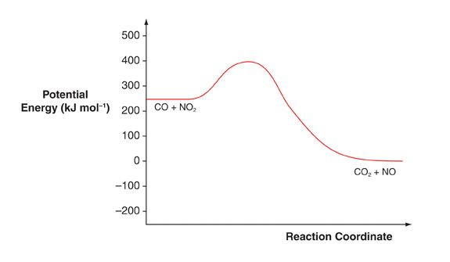

For the following reaction, choose the correct values for the enthalpy change and the activation energy.

CO2 + NO 🡪 CO + NO2

|  |  |  |  |  |  |
| --- | --- | --- | --- | --- | --- |
|  | | **Enthalpy change in kJ mol-1** | | **Activation Energy in kJ mol-1** | |
| (a) | | -400 | | -150 | |
| (b) | | +150 | | -400 | |
| (c) | | -400 | | +250 | |
| (d) | | +250 | | +400 | |

1. Which one of the following equations shows the reacting species only? (i.e. those actually consumed in the reaction)
2. CH3COOH(aq) + Ba(OH)2(aq) 🡪 Ba(CH3COO)2(aq) + H2O(l)
3. Mg(s) + O2(g) 🡪 MgO(s)
4. CaCO3(s) + 2HC(aq) 🡪 CaC2(aq) + H2O(l) + CO2(g)
5. Ca(OH)2(aq) + H2SO4(aq) 🡪 CaSO4(aq) + H2O(l)
6. A vessel is filled with 10 g of sulfur dioxide at 100°C. The vessel is evacuated, and filled with 5 g of another gas at the same temperature. Given that the new gas exerts twice as much pressure, what could the new gas be?
7. Methane
8. Oxygen
9. Carbon dioxide
10. Cyclohexane
11. A metal, M, forms a sulfate of formula MSO4 and molar mass 152. The chloride of M reacts with sodium hydroxide solution to form a precipitate of the metal hydroxide. What is the molar mass of the hydroxide?
12. 90
13. 56
14. 96
15. 146
16. What is the conjugate acid of the hydrogensulfate ion?
17. HSO4-
18. H2SO4
19. SO42-
20. H2S
21. The equilibrium constantfor pure water is measured to be 5.13 x 10-13 mol2 L-2 at 100°C. Which of the following is correct?
22. The concentration of H+ ions is 7.16 x 10-7 mol L-1 and the water is acidic.
23. The concentration of H+ ions is 7.16 x 10-7 mol L-1 and the water is neutral.
24. The concentration of OH- ions is 7.16 x 10-7 mol L-1 and the water is basic.
25. The concentration of OH- ions is 7.16 x 10-7 mol L-1 and the water is acidic.
26. 25 mL of a 0.010 mol L–1 solution of barium hydroxide (Ba(OH)2) is diluted by adding 225 mL of water at 25°C. What would be the pH of the resulting solution?
27. 2.00
28. 2.70
29. 11.00
30. 11.30
31. In which of the following equations is water acting as a Brønsted-Lowry base?
32. 2H2O + Na 🡪 2NaOH + H2
33. [Fe(H2O)6]3+ + H2O [Fe(OH)(H2O)5]2+ + H3O+
34. H2O + NH3 NH4+ + OH-
35. HPO42- + H2O OH- + H2PO4-
36. Which of the following will be oxidised by Br2 liquid?
37. Au(s)
38. C- in a solution of KC
39. Fe3+ in a solution of Fe(CH3COO)3
40. H2S in acidified aqueous solution
41. Despite having been invented in 1859, lead-acid batteries are still used in most vehicles. The overall equation for the reaction taking place when a lead-acid battery discharges is:

Pb + PbO2 + 2HSO4- + 2H+ 🡪 2PbSO4 + 2H2O

Which of the following represents the half-cell reaction at the positive electrode of the battery?

1. Pb + HSO4- 🡪 PbSO4 + H++ 2e-
2. PbSO4 + H++ 2e- 🡪 Pb + HSO4-
3. PbO2 + HSO4- + 3H+ + 2e- 🡪 PbSO4 + 2H2O
4. PbSO4 + 2H2O 🡪 PbO2 + HSO4- + 3H+ + 2e-
5. The diagram below shows the electrolysis of lead (II) bromide.

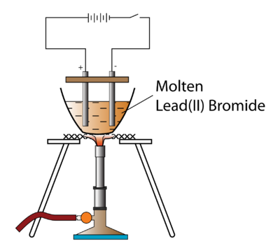

Which of the following statements is **false**?

1. A silvery-grey liquid would form at the cathode.
2. Bromine molecules act as the reductant and lead ions act as the oxidant.
3. The number of moles of lead formed would be the same as that of bromine.
4. Electrons would flow from the anode to the cathode in the external circuit.
5. Which of the following is the empirical formula of 1,3-dimethylcyclohexane?
6. C8H18
7. C8H16
8. CH2
9. C4H9
10. Which of the following are isomers of methyl propanoate?
11. methyl-1-propanol
12. ethyl ethanoate
13. butanoic acid
14. 2-butanone
15. methyl propanoic acid
16. (i), (ii) and (iii) only
17. (ii), (iii) and (iv) only
18. (iii), (iv) and (v) only
19. (ii), (iii) and (v) only
20. A student determined the following properties of an organic compound, X.

* X is neutral to moist litmus paper.
* On reaction with acidified sodium dichromate solution, the product turned moist litmus paper red.

Which of the following could be compound X?

1. Butanone
2. 1-butanol
3. 2-propanol
4. Ethanoic acid
5. Polypeptides are polymers made from amino acids. When amino acids join together to make polypeptides:
6. an addition polymerisation reaction takes place, with the elimination of water molecules.
7. new amide groups are formed.
8. double bonds in the amino acids must first be broken to allow them to join to one another.
9. a condensation reaction takes place, producing only the polymer and no other products.

**End of Section OneSection Two: Short answer 35% (70 Marks)**

This section contains **nine (9)** questions. Answer **all** questions. Write your answers in the space provided.

Spare pages are included at the end of this booklet. They can be used for planning your responses and/or as additional space if required to continue an answer.

* Planning: If you use the spare pages for planning, indicate this clearly at the top of the page.
* Continuing an answer: If you need to use the space to continue an answer, indicate in the original answer space where the answer is continued, i.e. give the page number. Fill in the number of the question(s) that you are continuing to answer at the top of the page.

Suggested working time: 60 minutes.

**Question 26 (9 marks)**

For each species listed in the table below, draw the Lewis structure, representing all valence shell electron pairs either as : or as — **and** state or sketch the shape of the species **and** state the polarity of the molecule.

|  |  |  |  |  |  |  |
| --- | --- | --- | --- | --- | --- | --- |
| (for example, water |  | or |  | or |  | bent, polar) |

|  |  |  |  |
| --- | --- | --- | --- |
| **Species** | **Structure (showing all valence electrons)** | **Shape (sketch or name)** | **Polarity of molecule (polar or non-polar)** |
| Hydrogen cyanide  HCN |  |  |  |
| Difluoromethane  CH2F2 |  |  |  |
| Sulfur trioxide  SO3 |  |  |  |

**Question 27 (5 marks)**

Trichloroethanoic acid (CC3COOH)is a weak acid that is sometimes used in the removal of warts and tattoos. It allows new skin cells to appear by removing the first few layers of skin. The sodium salt of the acid (sodium trichloroethanoate) is also used as a weedkiller.

1. Write an equation to show the reaction that takes place when trichloroacetic acid is dissolved in water. (1 mark)

_____________________________________________________________________________

1. State and explain what would happen to the pH (increase, decrease, or no change) of a

1 mol L-1 trichloroethanoic acid solution if it were mixed with a solution of sodium trichloroethanoate. (4 marks)

**Effect on pH (circle one)** Increases Decreases No change

Reason

_____________________________________________________________________________

_____________________________________________________________________________

_____________________________________________________________________________

_____________________________________________________________________________

_____________________________________________________________________________

**Question 28 (5 marks)**

Give the name (or formula) of the species that match each of the following descriptions.

1. The conjugate base of carbonic acid. ___________________________ (1 mark)
2. A tertiary alcohol with 4 carbon atoms. ___________________________ (1 mark)
3. A diatomic element with a triple bond. ___________________________ (1 mark)
4. A network covalent compound. ___________________________ (1 mark)
5. A polar oxide of carbon. ___________________________ (1 mark)

**Question 29 (11 marks)**

1. Tribromobenzene is an important intermediate in drug manufacture, and can be made by reacting benzene (C6H6) with bromine in the presence of an aluminium bromide catalyst. Write an equation for the reaction of benzene with bromine to produce tribromobenzene. (2 marks)

_____________________________________________________________________________

1. Tribromobenzene can exist as one of three isomers. Draw the structure and give the name of each of these isomers in the table below. (6 marks)

|  |  |
| --- | --- |
| **Structure** | **Name** |
|  |  |
|  |  |
|  |  |

1. The reaction between bromine and propene does not require a catalyst, and will occur in the dark. Write a balanced equation for the reaction and give details of what you would observe as the reaction takes place. (3 marks)

|  |  |  |
| --- | --- | --- |
| *Equation* |  | |
| *Observation* | |  |
|  |  | |

**Question 30 (10 marks)**

Provide explanations for each of the following observations.

1. 2-bromo-2-butene exhibits geometric isomerism but 2-bromo-1-butene does not. (3 marks)

_____________________________________________________________________________

_____________________________________________________________________________

_____________________________________________________________________________

_____________________________________________________________________________

_____________________________________________________________________________

_____________________________________________________________________________

1. Hydrogen chloride (boiling point -85°C) is a more polar molecule than hydrogen bromide, but hydrogen bromide boils at a higher temperature (-66.8°C). (3 marks)

_____________________________________________________________________________

_____________________________________________________________________________

_____________________________________________________________________________

_____________________________________________________________________________

_____________________________________________________________________________

_____________________________________________________________________________

1. Sodium is a soft, malleable material, but sodium chloride is hard and brittle. (4 marks)

_____________________________________________________________________________

_____________________________________________________________________________

_____________________________________________________________________________

_____________________________________________________________________________

_____________________________________________________________________________

_____________________________________________________________________________

_____________________________________________________________________________

_____________________________________________________________________________

**Question 31 (7 marks)**

0.0100 mol L-1 potassium hydroxide was placed in a burette, and titrated against 20.0 mL aliquots of 0.0100 mol L-1 hydrofluoric acid. The pH of the solution was measured using a pH probe after the addition of each 1.00 mL of potassium hydroxide until 40.0 mL had been added. The results of the experiment are shown in the graph below:

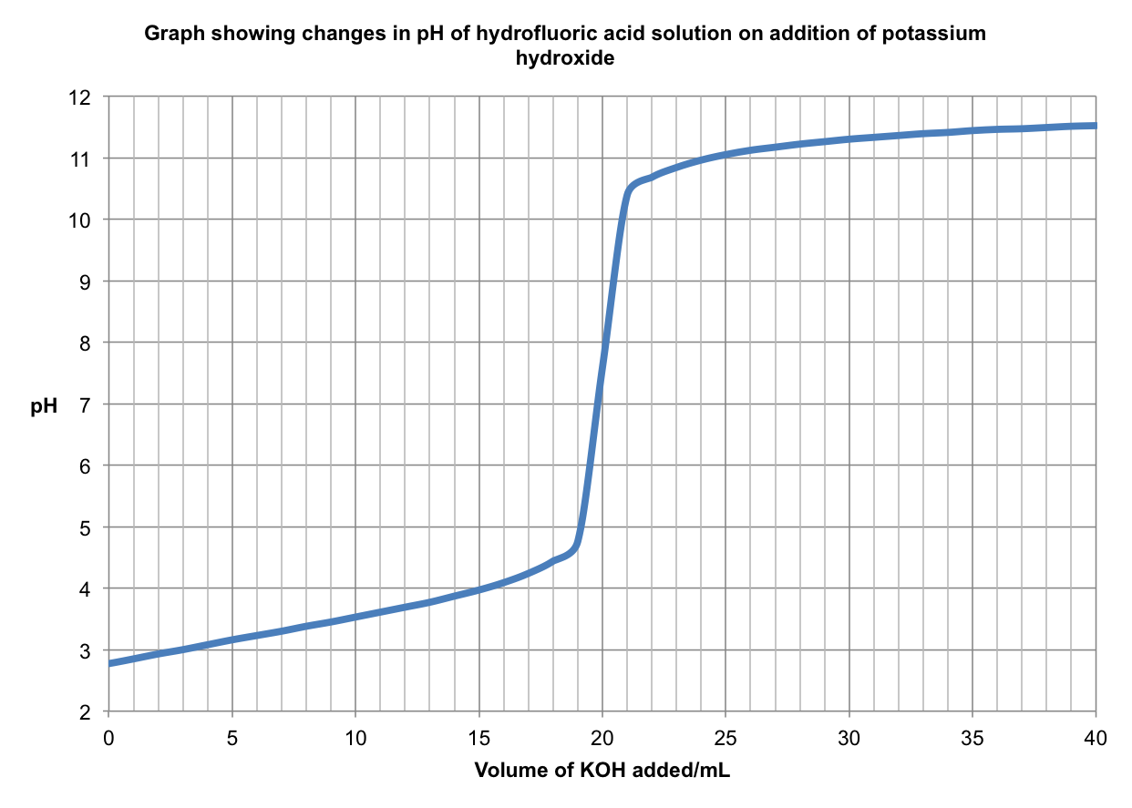

The measured pH at the start of the experiment was 2.77.

1. Determine the percentage of hydrogen fluoride molecules that were ionised. (2 marks)

_____________________________________________________________________________

_____________________________________________________________________________

_____________________________________________________________________________

_____________________________________________________________________________

1. Explain why the pH at the equivalence point was not 7. (3 marks)

_____________________________________________________________________________

_____________________________________________________________________________

_____________________________________________________________________________

_____________________________________________________________________________

A similar experiment was carried out to determine the concentration of ethanoic acid in a verruca remedy (verrucas are similar to warts, and are commonly found on the feet). A solution of the remedy was prepared by dissolving a 5.00 mL portion in water and making the solution up to

250 mL in a volumetric flask. 20.0 mL aliquots of it were titrated against the same solution of potassium hydroxide. The experiment was carried out without a pH probe, using methyl orange as an indicator.

1. Explain what effect this choice of indicator would have on the calculated value of the acid concentration. (2 marks)

_____________________________________________________________________________

_____________________________________________________________________________

_____________________________________________________________________________

_____________________________________________________________________________

**Question 32 (4 marks)**

Give the IUPAC name of the following compounds.

|  |  |
| --- | --- |
| **Formula** | **Name** |
| CH3(CH2)5CH(OH)CH3 |  |
| CH3CH2COOCH2CH3 |  |
| CH3CH2COCH2CH3 |  |
| CH3CH2CH2CHO |  |

**Question 33 (6 marks)**

In an experiment designed to investigate the effect of sweating on body temperature, a student wrapped the bulb of a thermometer in tissue paper, and then dipped this in water. The thermometer was removed from the water, and held in a breeze from a nearby fan. After a short time, the student noticed that the paper had dried out, and that the temperature on the thermometer had fallen.

1. Explain, in terms of kinetic theory, why the temperature fell during the experiment. (3 marks)

_____________________________________________________________________________

_____________________________________________________________________________

_____________________________________________________________________________

_____________________________________________________________________________

_____________________________________________________________________________

_____________________________________________________________________________

The experiment was then repeated, but the thermometer was dipped in sodium chloride solution instead of water.

1. State and explain how the temperature change would be expected to differ from the first experiment. (3 marks)

_____________________________________________________________________________

_____________________________________________________________________________

_____________________________________________________________________________

_____________________________________________________________________________

_____________________________________________________________________________

_____________________________________________________________________________

**Question 34 (13 marks)**

Kevlar is a synthetic fibre used in windsurfing sails and bulletproof vests. Like Nylon and Rayon, it is a condensation polymer, but its breaking strength is around ten times that of Nylon. The structure of Kevlar is shown below, with its repeating unit in bold.

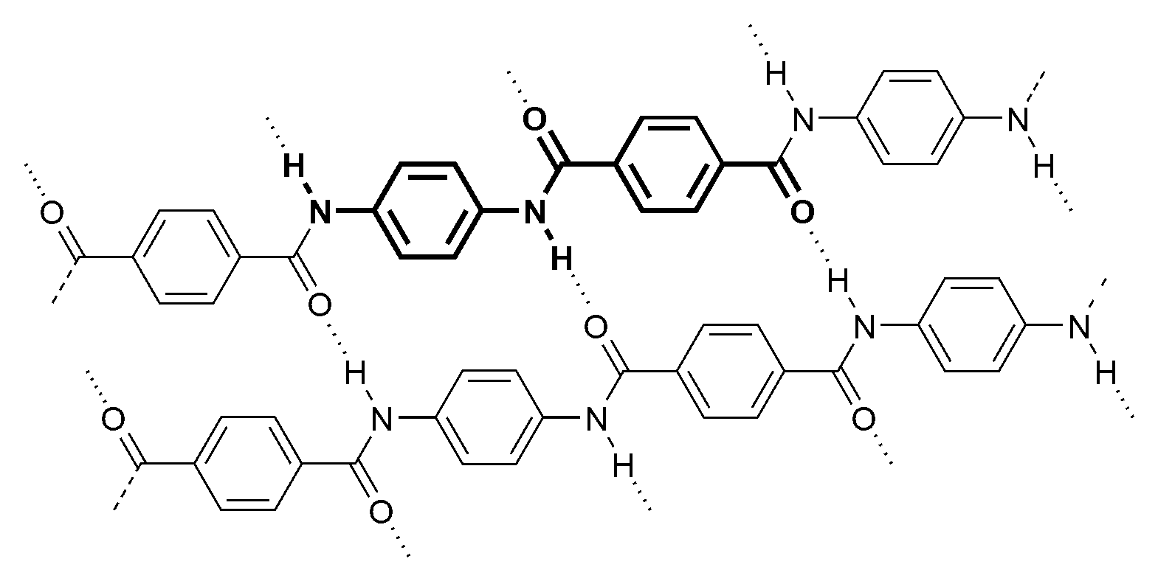

1. Draw the structure of two monomers that could be used to make Kevlar.

(2 marks)

|  |  |
| --- | --- |
| **Monomer 1** | **Monomer 2** |
|  |  |

Polyvinyl alcohol (PVA) is an unusual addition polymer, in the sense that it is not made by building up single-precursor molecules known as monomers. Instead, it is made by hydrolysing another polymer, polyvinyl acetate. This polymer is built up using the monomer vinyl acetate, whose formula is CH3COOCHCH2, and whose skeletal formula is shown below.

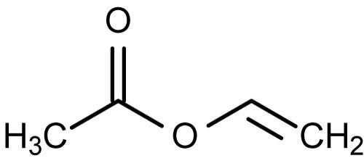

1. Identify any functional groups present in this molecule by **circling** them and **naming** them on the skeletal formula. (2 marks)
2. In the space below, draw the structure of a length of polyvinyl acetate that would form from three vinyl acetate molecules. (2 marks)

|  |
| --- |
|  |

The process of hydrolysis involves dissolving the polyvinyl acetate in methanol, and then reacting it with sodium hydroxide.

1. Use your knowledge of intermolecular forces to explain why polyvinyl acetate is soluble in methanol. You may use a diagram to aid your explanation. (2 marks)

_____________________________________________________________________________

_____________________________________________________________________________

_____________________________________________________________________________

_____________________________________________________________________________

_____________________________________________________________________________

1. Write an equation to represent the reaction between sodium hydroxide and vinyl acetate.

(2 marks)

_____________________________________________________________________________

Early in 2012, chemists working at Hanyang University in Korea were able to synthesise the toughest polymer yarn known at the time by mixing PVA with carbon nanotubes (CNTs) during the spinning of the yarns. One type of fibre, which was manufactured using PVA (polyvinyl alcohol) and single-walled carbon nanotubes (SWCNTs), had a toughness of 870 J/g, making it far stronger than spider silk (165 J/g) and more than ten times as strong as Kevlar (78 J/g).

|  |  |
| --- | --- |
|  | Carbon nanotubes are an allotrope of carbon whose structure is shown in the picture, and is similar to that of graphite. They were discovered in 1991 as a spin-off from research into Buckminsterfullerenes, and have since found uses in a huge variety of applications, from medicine to electronics and molecular manufacturing. |

1. With reference to the structure and bonding present, explain whether or not you would expect carbon nanotubes to be able to conduct electricity. (3 marks)

_____________________________________________________________________________

_____________________________________________________________________________

_____________________________________________________________________________

_____________________________________________________________________________

_____________________________________________________________________________

_____________________________________________________________________________

_____________________________________________________________________________

**End of Section TwoSection Three: Extended answer 40% (80 marks)**

This section contains **five (5)** questions. You must answer **all** questions. Write your answers in the spaces provided.

Where questions require an explanation and/or description, marks are awarded for the relevant

chemical content and also for coherence and clarity of expression.

Final answers to calculations should be expressed to three (3) significant figures and include appropriate units.

Spare pages are included at the end of this booklet. They can be used for planning your

responses and/or as additional space if required to continue an answer.

* Planning: If you use the spare pages for planning, indicate this clearly at the top of the page.
* Continuing an answer: If you need to use the space to continue an answer, indicate in the

original answer space where the answer is continued, i.e. give the page number. Fill in the

number of the question(s) that you are continuing to answer at the top of the page.

Suggested working time: 70 minutes*.*

**Question 34 (21 marks)**

|  |  |
| --- | --- |
| The diagram shows a fuel injector of the type used in many combustion engines. The engine management system causes the needle valve to open and then close, ensuring that a precise amount of fuel enters the cylinder. The fuel enters the cylinder as a fine mist, and mixes with air. The cylinder then compresses the fuel-air mixture to around one tenth of its original volume  Modern combustion engines running on unleaded petrol use fuel composed mainly of octane and isomers of octane. The research octane number (RON) gives an indication as to the composition of the mixture |  |

1. One common isomer of octane present in petrol is 2,2,4-trimethylpentane. State and explain how you would expect the boiling points of octane and 2,2,4-trimethylpentane to compare. (3 marks)

_____________________________________________________________________________

_____________________________________________________________________________

_____________________________________________________________________________

_____________________________________________________________________________

_____________________________________________________________________________

1. Write a balanced equation for the complete combustion of octane. (2 marks)

_____________________________________________________________________________

1. Using collision theory, explain the effect on the rate of the combustion reaction of the following reaction conditions.
   1. Injecting the fuel as a fine mist. (2 marks)

_____________________________________________________________________________

_____________________________________________________________________________

_____________________________________________________________________________

* 1. Compressing the air-fuel mixture prior to ignition. (2 marks)

_____________________________________________________________________________

_____________________________________________________________________________

_____________________________________________________________________________

1. At a normal engine operating temperature of 1000°C, an injector injects 1.00 g of fuel for every 60.0 litres of air entering the cylinder at atmospheric pressure. Assuming all the components of the fuel have the molecular formula C8H18, and that air is exactly 20% oxygen by volume, find the limiting reagent. (5 marks)

_____________________________________________________________________________

_____________________________________________________________________________

_____________________________________________________________________________

_____________________________________________________________________________

_____________________________________________________________________________

_____________________________________________________________________________

1. Calculate the mass of any unused reactant from the above reaction mixture. (2 marks)

_____________________________________________________________________________

_____________________________________________________________________________

_____________________________________________________________________________

_____________________________________________________________________________

Since regulations governing emissions from motor vehicles have become stricter, fuel injection technology is found on most newly manufactured vehicles, owing to the fact that it significantly reduces the occurrence of incomplete combustion.

1. With reference to the products of the reaction, explain why it is important to prevent this reaction occurring. (2 marks)

_____________________________________________________________________________

_____________________________________________________________________________

As concern over the effect of burning fossil fuels mounts, alternatives are being sought to the internal combustion engine.

|  |  |
| --- | --- |
| The photograph shows a proton exchange membrane (PEM) fuel cell, capable of offering outputs of up to 250 kW. Whilst not as efficient as some other designs of fuel cell, this type of cell offers the advantage that it runs at low temperatures and consists of a solid, flexible electrolyte that will not leak. As a result, this type of fuel cell is particularly well suited to use in automotive applications. The cell uses hydrogen as its fuel, which is combined with oxygen to produce water. |  |

1. State the cell voltage that can be obtained from a single fuel cell such as this. (1 mark)

_____________________________________________________________________________

1. State TWO environmental advantages of the use of fuel cells to power motor vehicles, compared to combustion engines. (2 marks)

_____________________________________________________________________________

_____________________________________________________________________________

**Question 35 (21 marks)**

A student conducted a series of experiments to investigate the physical and chemical properties of basic solutions. In the first experiment, she made a solution by dissolving 10.0 g of barium hydroxide in 250 mL of water.

1. Calculate the pH of this solution. (5 marks)

_____________________________________________________________________________

_____________________________________________________________________________

_____________________________________________________________________________

_____________________________________________________________________________

_____________________________________________________________________________

_____________________________________________________________________________

_____________________________________________________________________________

_____________________________________________________________________________

1. During the experiment, the electrical conductivity of the solution was measured. It was observed to be high at the start of the experiment. As the acid was added, it fell to zero and then increased again. Explain these observations. (4 marks)

_____________________________________________________________________________

_____________________________________________________________________________

_____________________________________________________________________________

_____________________________________________________________________________

_____________________________________________________________________________

_____________________________________________________________________________

_____________________________________________________________________________

Wanting to carry out experiments on basic solutions found outside of the laboratory, the student decided to investigate milk of magnesia. Reading the information on the label, the student realised that this was a saturated solution of magnesium hydroxide in water. The mixture gets its name from the fact that undissolved solid is suspended in the liquid, giving it a milky appearance.

In the mixture, the following reaction takes place:

Mg(OH)2(s) Mg2+(aq) + 2OH-(aq)

1. Write an expression for the equilibrium constant, K, for the above reaction. (1 mark)

_____________________________________________________________________________

1. Explain whether you would you expect the value of K to be greater than one (> 1) or less than one (< 1). (2 marks)

_____________________________________________________________________________

_____________________________________________________________________________

_____________________________________________________________________________

The student wanted to know whether the mass of solid present in the mixture could be affected by various changes. The mixture was divided equally amongst four beakers, and the student filtered the mixtures after each experiment to find the mass of undissolved magnesium hydroxide. One beaker was left unchanged to act as a control.

1. For each of the changes described below, predict and explain what effect the change would have on the mass of solid present once the system had returned to equilibrium.
2. Distilled water was added to the mixture. (3 marks)

|  |  |  |  |
| --- | --- | --- | --- |
| **Effect on mass of solid**  **(circle one)** | INCREASE | DECREASE | NO CHANGE |

Explanation

_____________________________________________________________________________

_____________________________________________________________________________

_____________________________________________________________________________

_____________________________________________________________________________

1. A few drops of vinegar were added to the mixture. (3 marks)

|  |  |  |  |
| --- | --- | --- | --- |
| **Effect on mass of solid**  **(circle one)** | INCREASE | DECREASE | NO CHANGE |

Explanation

_____________________________________________________________________________

_____________________________________________________________________________

_____________________________________________________________________________

_____________________________________________________________________________

The student put a third beaker in the fridge. When he removed it, he noticed that the mass of solid had increased compared to the control beaker.

1. Explain what information this gives us about the enthalpy of the products of the reaction compared to that of the reactants. (3 marks)

_____________________________________________________________________________

_____________________________________________________________________________

_____________________________________________________________________________

_____________________________________________________________________________

_____________________________________________________________________________

_____________________________________________________________________________

**Question 36 (14 marks)**

In order to find the formula of hydrated copper(II) sulfate, CuSO4.*n*H2O, 5.02 g of the hydrated sulfate was dissolved in water, and the solution made up to 100 mL. To this solution was added excess potassium iodide, forming iodine according to the following equation:

2Cu2+(aq) + 4I-(aq) 🡪 2CuI(s) + I2(aq)

1. Use the concept of oxidation numbers to show which species were oxidised and reduced in this process. (3 marks)

_____________________________________________________________________________

_____________________________________________________________________________

_____________________________________________________________________________

_____________________________________________________________________________

_____________________________________________________________________________

_____________________________________________________________________________

10.0 mL portions of the resulting solution containing iodine were titrated using 0.100 mol L-1 sodium thiosulfate solution (Na2S2O3), 20.02 mL being required for complete reaction. In this titration, thiosulfate ions reduce iodine to iodide, and are converted to tetrathionate ions (S4O62-).

1. Write ionic half-equations to show the reduction and oxidation processes taking place.

(2 marks)

|  |  |
| --- | --- |
| **Reduction** |  |
| **Oxidation** |  |

1. Write an overall ionic equation to show the reaction between thiosulfate ions and iodine.

(1 mark)

_____________________________________________________________________________

1. Calculate the number of moles of copper ions in the original 5.02 g sample of hydrated copper(II) sulfate. (4 marks)

_____________________________________________________________________________

_____________________________________________________________________________

_____________________________________________________________________________

_____________________________________________________________________________

_____________________________________________________________________________

_____________________________________________________________________________

_____________________________________________________________________________

_____________________________________________________________________________

1. Find the value of *n* in the formula of this hydrated sulfate and write its correct formula.

(4 marks)

_____________________________________________________________________________

_____________________________________________________________________________

_____________________________________________________________________________

_____________________________________________________________________________

_____________________________________________________________________________

_____________________________________________________________________________

_____________________________________________________________________________

_____________________________________________________________________________

**Question 37 (16 marks)**

Amino acids are the building blocks of proteins in biological systems, as well as playing important roles as intermediates in metabolism. There are 20 naturally occurring amino acids found in proteins. Ten of these are produced within the human body. The other ten, known as *essential* amino acids, must be obtained from food. Failure to obtain sufficient quantities of these can lead to degradation of the body’s proteins. Since the body cannot store amino acids, it is therefore important that these *essential* amino acids are in food every day.

The simplest amino acid found in proteins is known as glycine. The skeletal formula of glycine is shown below.

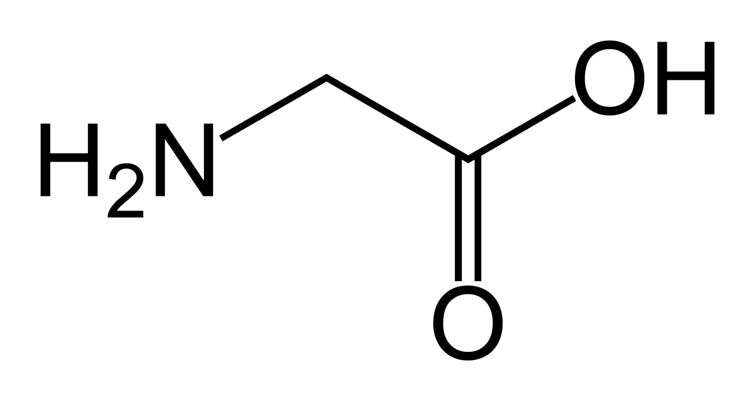

In neutral solutions, glycine is found in a *zwitterion* form. Solutions of this ion can act as buffers.

1. Draw the structure of this ion in the space below. (1 mark)
2. Using equations to illustrate your answer, explain how glycine in its *zwitterion* form is able to act as a buffer. (3 marks)

_____________________________________________________________________________

_____________________________________________________________________________

_____________________________________________________________________________

_____________________________________________________________________________

_____________________________________________________________________________

Lysine is one of the ten *essential* amino acids. Elemental analysis shows that it is composed of the elements nitrogen, hydrogen, carbon, and oxygen. In an experiment to find its empirical formula, 2.175 g of lysine was combusted, producing 3.93 g of carbon dioxide and 1.87 g of water vapour. In a separate experiment, 1.986 g of lysine was reacted to turn all the nitrogen present into ammonia. It was found that 0.462 g of ammonia was formed.

1. Determine the empirical formula of lysine. (8 marks)

_____________________________________________________________________________

_____________________________________________________________________________

_____________________________________________________________________________

_____________________________________________________________________________

_____________________________________________________________________________

_____________________________________________________________________________

_____________________________________________________________________________

_____________________________________________________________________________

_____________________________________________________________________________

_____________________________________________________________________________

_____________________________________________________________________________

_____________________________________________________________________________

_____________________________________________________________________________

_____________________________________________________________________________

_____________________________________________________________________________

_____________________________________________________________________________

_____________________________________________________________________________

_____________________________________________________________________________

_____________________________________________________________________________

_____________________________________________________________________________

_____________________________________________________________________________

_____________________________________________________________________________

Another sample of lysine, weighing 1.68 g, was heated in the absence of air. It was found that the vapour occupied a volume of 549 mL at 100°C and 100 kPa.

1. Find the molecular formula of lysine (4 marks)

_____________________________________________________________________________

_____________________________________________________________________________

_____________________________________________________________________________

_____________________________________________________________________________

_____________________________________________________________________________

_____________________________________________________________________________

**Question 38 (8 marks)**

Primary standard solutions are important in many forms of volumetric analysis. Potassium permanganate solution (in redox titrations), hydrochloric acid solution and sodium hydroxide (in acid-base titrations) are commonly used secondary standards, and are usually standardised against primary standards before use in volumetric analysis. Examples of substances that can be used as primary standards are sodium carbonate decahydrate (Na2CO3.10H2O) and oxalic acid (C2H2O4.2H2O).

Outline how a primary standard solution could be made in the laboratory. Marks will be awarded for relevant chemical content in your answer, and also for coherence and clarity of expression. Your answer does NOT need to include any calculations.

You should include equations where relevant, and focus on the following areas:

* important features of a primary standard;
* why substances such as potassium permanganate, hydrochloric acid and sodium hydroxide are not suitable for use as primary standards;
* steps taken, and equipment used in the preparation of a primary standard solution in order to minimise the potential for error.

_____________________________________________________________________________

_____________________________________________________________________________

_____________________________________________________________________________

_____________________________________________________________________________

_____________________________________________________________________________

_____________________________________________________________________________

_____________________________________________________________________________

_____________________________________________________________________________

_____________________________________________________________________________

_____________________________________________________________________________

_____________________________________________________________________________

_____________________________________________________________________________

_____________________________________________________________________________

_____________________________________________________________________________

_____________________________________________________________________________

_____________________________________________________________________________

_____________________________________________________________________________

_____________________________________________________________________________

_____________________________________________________________________________

_____________________________________________________________________________

_____________________________________________________________________________

_____________________________________________________________________________

_____________________________________________________________________________

_____________________________________________________________________________

_____________________________________________________________________________

_____________________________________________________________________________

_____________________________________________________________________________

_____________________________________________________________________________

_____________________________________________________________________________

_____________________________________________________________________________

_____________________________________________________________________________

_____________________________________________________________________________

_____________________________________________________________________________

_____________________________________________________________________________

_____________________________________________________________________________

_____________________________________________________________________________

_____________________________________________________________________________

_____________________________________________________________________________

_____________________________________________________________________________

_____________________________________________________________________________

_____________________________________________________________________________

_____________________________________________________________________________

**End of questions**

**Additional working space**

_____________________________________________________________________________

_____________________________________________________________________________

_____________________________________________________________________________

_____________________________________________________________________________

_____________________________________________________________________________

_____________________________________________________________________________

_____________________________________________________________________________

_____________________________________________________________________________

_____________________________________________________________________________

_____________________________________________________________________________

_____________________________________________________________________________

_____________________________________________________________________________

_____________________________________________________________________________

_____________________________________________________________________________

_____________________________________________________________________________

_____________________________________________________________________________

_____________________________________________________________________________

_____________________________________________________________________________

_____________________________________________________________________________

_____________________________________________________________________________

_____________________________________________________________________________

_____________________________________________________________________________

_____________________________________________________________________________

_____________________________________________________________________________

_____________________________________________________________________________

_____________________________________________________________________________

_____________________________________________________________________________

_____________________________________________________________________________

**Additional working space**

_____________________________________________________________________________

_____________________________________________________________________________

_____________________________________________________________________________

_____________________________________________________________________________

_____________________________________________________________________________

_____________________________________________________________________________

_____________________________________________________________________________

_____________________________________________________________________________

_____________________________________________________________________________

_____________________________________________________________________________

_____________________________________________________________________________

_____________________________________________________________________________

_____________________________________________________________________________

_____________________________________________________________________________

_____________________________________________________________________________

_____________________________________________________________________________

_____________________________________________________________________________

_____________________________________________________________________________

_____________________________________________________________________________

_____________________________________________________________________________

_____________________________________________________________________________

_____________________________________________________________________________

_____________________________________________________________________________

_____________________________________________________________________________

_____________________________________________________________________________

_____________________________________________________________________________

_____________________________________________________________________________

_____________________________________________________________________________